FAMILY VIOLENCE PACKET

OCA_____-___________DATE OF ASSAULT___________DATE OF REPORT_________

Victim Information:
Name: (Last, First, Middle):_____________________________ DOB:______________
Home Address (Street):____________________________(City/State):___________Zip:______
Driver’s License:_____________________ SSN#:_____________ Phone:______________
Place of Employment/Address:_______________________________ Work Phone:__________
Emergency Points of Contact:
Contact 1:
Name:_______________________________ DOB/Age:_____________________
Address:_____________________________ Phone:________________________
Relationship:__________________________
Contact 2:
Name:_______________________________ DOB/Age:_____________________
Address:_____________________________ Phone:________________________
Relationship:__________________________
Victim/Suspect Relationship:
€ Dating/Engaged___yrs___months € Marriage-Legal___yrs___months € Household Member
€ Former Household Member € Biological Parent € Blood Relation € Rel. Ended (date)______
Nature of Assault:
€ Striking <circle> (open hand, closed hand, elbow, kicking, other:_____________)
€ Pushing/ Shoving/ Throwing € Grabbing/ Pulling Body € Grabbing/ Pulling Hair
€ Biting € Strangulation/ Suffocation € Strangulation Supplement Attached
€ Other Not Listed: __________________________________________________
Consent to Photos (YES / NO) If no, proceed to warrant: (YES / NO)
Assault Details:
How long has it been since the assault?________Hours_______Minutes________Days
Interference with Emergency Phone Call (explain how, detail):___________________________
_____________________________________________________________________________
Weapons Involved? (Make)____________(Model)____________(Caliber)___________(Color)_______
Other Weapon Type:___________________________________________________________________
Does suspect have access to weapons (YES / NO). Describe weapons accessible:___________________
____________________________________________________________________________________
Does suspect have CHL (YES / NO)
Did suspect threaten you if you called the Police for this assault (YES/ NO)
Describe the nature of the threat:__________________________________________________________
____________________________________________________________________________________
Was suspect using drugs/narcotics at the time of the assault (YES / NO)__________________________
Does suspect use the following: € Alcohol € Prescriptions € Illicit Drugs
Continuous Violence Against the Family Screening:
Has the suspect assaulted you before? (YES / NO) Date/Location of previous assault:_______________
Number of Assaults Previous 12 months:_______ Was a report filed with Law Enforcement: (YES / NO)
Agency report filed with:__________________ Report Number:_____________
Has suspect ever threatened a member of your family, household, or pets: (YES / NO)________________
Emergency Protective Order:
Request for EPO: € YES € NO Current PO in Place? € YES € NO PO #:____________________

BODY INJURY DIAGRAM
Mark all injuries on both the Victim and the Suspect

VICTIM: Height:________; Weight:___________; Sex:__________

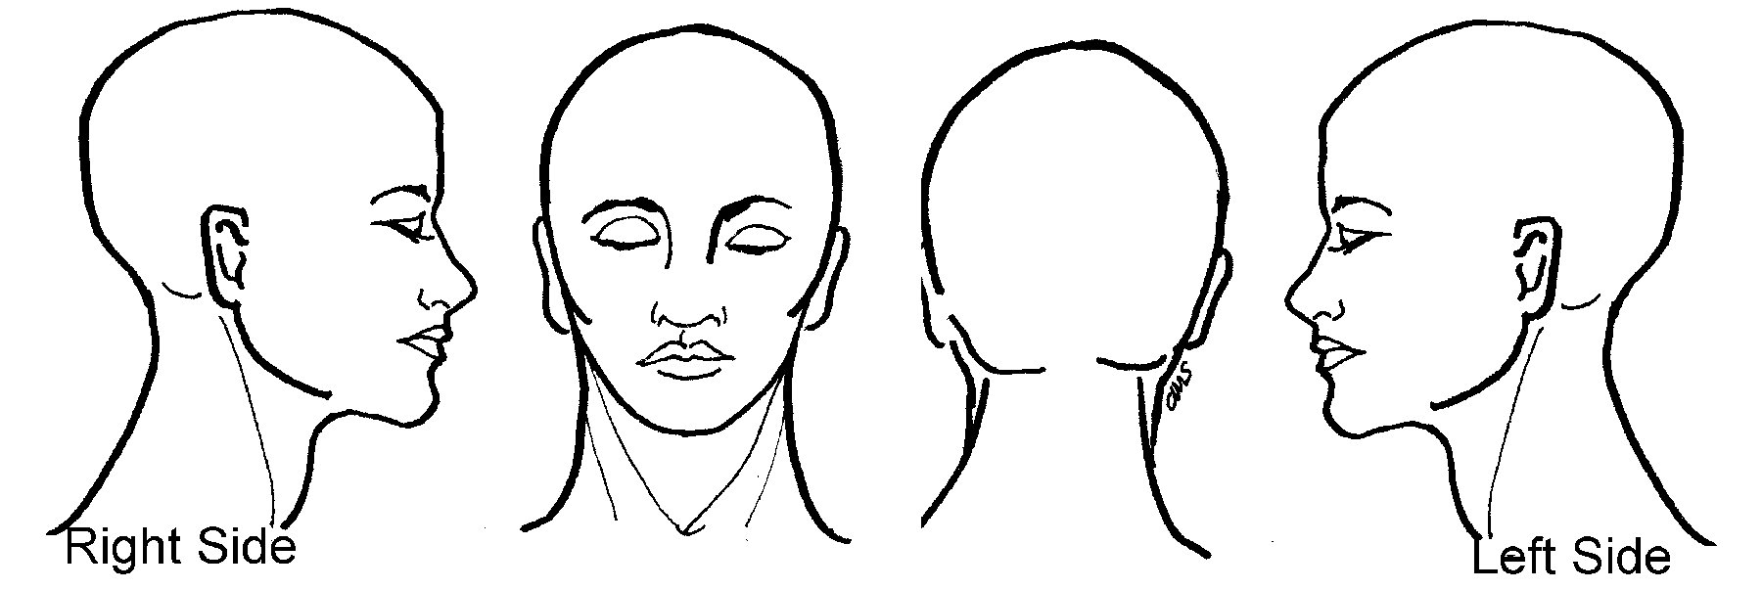

SUSPECT: Height:________; Weight:___________; Sex:__________

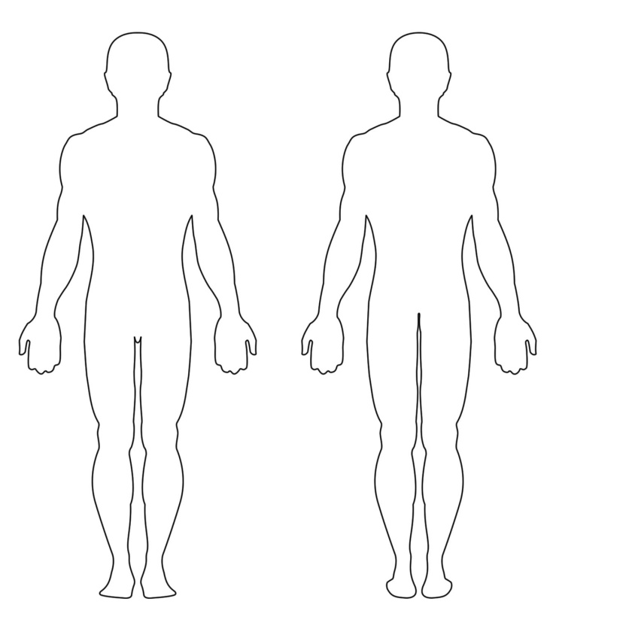
VICTIM SUSPECT
Victim Description:
Demeanor: Physical Condition: Appearance: Speech:
€ Afraid € Hysterical € Abrasions € Loose Hair € Bloody Clothes € Angry

€ Angry € Indifferent € Bruise-New € Shaking € Smeared Makeup € Exasperated

€ Apologetic € Intoxicated € Bruise-Old € Redness € Soiled/Sweaty € Excited/Fast

€ Distraught € Irrational € Bleeding € Swelling € Messy Hair € Crying

€ Calm € Nervous € Fracture € Lacerations € Torn/Pulled Clothes € Other______

Other Observations:___________________________________________________________________
_____________________________________________________________________________________

Suspect Information:
Name: (Last, First, Middle):_____________________________ DOB:______________
Home Address (Street):____________________________(City/State):___________Zip:______
Driver’s License:_____________________ SSN#:_____________ Phone:______________
Place of Employment/Address:_______________________________ Work Phone:__________
Military:________________________________________
Arrest Information: € On View Arrest € Report Only (Not on scene)
Miranda Warning: € YES (If yes attach Miranda Warning Card or Affidavit of Fact w/Miranda to report) € NO

Suspect Description:
Demeanor: Physical Condition: Appearance: Speech:
€ Afraid € Hysterical € Abrasions € Loose Hair € Bloody Clothes € Angry

€ Angry € Indifferent € Bruise-New € Shaking € Smeared Makeup € Exasperated

€ Apologetic € Intoxicated € Bruise-Old € Redness € Soiled/Sweaty € Excited/Fast

€ Distraught € Irrational € Bleeding € Swelling € Messy Hair € Crying

€ Calm € Nervous € Fracture € Lacerations € Torn/Pulled Clothes € Other______

Other Observations:___________________________________________________________________
_____________________________________________________________________________________

Crime Scene Observations: _____________________________________________________________
_____________________________________________________________________________________
_____________________________________________________________________________________
Photos Taken: (YES / NO)

Child Information:
Present: € YES € NO Forensic Interview: € YES € NO CPS Notification: € YES € NO
CPS Intake #:____________ CPS Intake Employee Name:__________________
Name of Child’s School/Daycare:_________________________________________________________
____________________________________________________________________________________
Witness Contact Information:
Name: (Last, First, Middle):_____________________________ DOB:______________
Home Address (Street):____________________________(City/State):___________Zip:______
Driver’s License:_____________________ SSN#:_____________ Phone:______________
Place of Employment/Address:_______________________________ Work Phone:__________

Name: (Last, First, Middle):_____________________________ DOB:______________
Home Address (Street):____________________________(City/State):___________Zip:______
Driver’s License:_____________________ SSN#:_____________ Phone:______________
Place of Employment/Address:_______________________________ Work Phone:__________

Name: (Last, First, Middle):_____________________________ DOB:______________
Home Address (Street):____________________________(City/State):___________Zip:______
Driver’s License:_____________________ SSN#:_____________ Phone:______________
Place of Employment/Address:_______________________________ Work Phone:__________

Family Violence Procedure:
Victim provided NOTICE TO ADULT VICTIMS OF FAMILY VIOLENCE card pursuant to C.C.P. Article 5.04? € YES € NO
Officer Providing Notification:____________________________ Badge #:____________________
Was hold placed on arrested suspect upon book-in? € YES € NO € N/A No Arrest
Was Victim Notification Card filed with Book-In? € YES € NO € N/A No Arrest

REQUEST FROM LAW ENFORCEMENT FOR RELEASE OF PROTECTED HEALTH INFORMATION

Name of Patient: ____________________________ Phone: _____________________
Other Names Used: __________________________ D.O.B. _____________________
SSN: _________________________________
I, the undersigned, authorize the release of or request access to the information specified below from the medical record(s) of the above-named patient.

Please check the appropriate legal exception that will allow the requested information to be released:
€ Suspect, Fugitive, Material Witness, or Missing Person, I certify that the information about the above named patient is needed to assist in attempting to identify or locate at suspect, fugitive, material witness, or missing person. I understand that the information I can obtain is limited under federal law. (45CFR §§ 164.512(f)(2).)
€ Injury by violence, The information sought concerns a person suffering or has suffered from a wound or injury inflicted by and act of Family Violence/ Domestic Violence that must be investigated by law enforcement under Texas law.
€ Child or Elder Abuse, The Information is sought pursuant to an investigation of a suspected child abuse, assault, injury, neglect or child sexual abuse, exploitation , or injury suffered as a result of human trafficking.
€ Victim of a Crime, The information sought concerns a possible victim of a crime in a situation not otherwise covered by other categories on this form. I certify that the information is needed to determine whether a violation of law by someone other than the victim has occurred, that the information is not intended to be used against the victim.
€ Patient Authorization, I have received written authorization from the patient for the release of medical information (see below).

Date(s) of Treatment (if known)__________________________________________________________

Information to be released or accessed:
€ Emergency Room Records € Radiology Reports € Behavioral Health € Face Sheet
€ Discharge/Death Summary € Radiology Images € Discharge Instructions
€ History & Physical € Consultation Report € Operative Reports
€ Lab/Pathology Report € Other:_______________________________________

Format requested by paper (hardcopy).

Method of Delivery (to be completed by CID Investigator):
€ Pick Up € Mail to Address Listed Below

_______________________________________________ may release the above information to:
(Hospital Name)

_______________________________________________________________________________
(Name of Agency Representative)

_______________________________________________________________________________
(Address of Agency) (Phone Number)

I understand that my records are confidential and cannot be disclosed without my written authorization, except when otherwise permitted by law. Information used or disclosed pursuant to this authorization may be subject to re-disclosure by the recipient and no longer protected. I understand that the specified information to be released may include, but is not limited to: history, diagnoses, and/or treatment of drug or alcohol abuse, mental illness, or communicable disease, including Human Immunodeficiency Virus (HIV) and Acquired Immune Deficiency Syndrome (AIDS).

I understand that treatment or payment cannot be conditioned on my signing this authorization except in certain circumstances such as participation in research programs, or authorization of the release of testing results for pre-employment purposes. I understand that I may revoke this authorization in writing at any time except to the extent that action has been taken in reliance upon this authorization.

Date: ______________________ Signature:_______________________________
(Patient or Legal Representative)

________________________________________
(Printed Name)

