AGENCY NAME STRANGULATION SUPPLEMENT TO BE COMPLETED IN ADDITION TO AFFIDAVIT OF FACT
CASE # _______-________________ DATE OF ASSAULT ____________________ TODAY’S DATE ____________________
VICTIM INFORMATION TO BE COMPLETED BY POLICE OFFICER: Officer Name________________ Badge #_____________
Victim’s Name (last, first, middle) _________________________________________________________________DOB_________________R/S____ ___
Method and/or Manner (how was Victim strangled) One Hand - R One Hand - L Two Hands Forearm Knee/Foot Chokehold Other (explain) ____________________________________________________________________________________________________
Is the Suspect right or left handed? Right Handed Left Handed Estimate how long you were strangled _________ Minute(s) _____________ Second(s) Multiple times? Yes #_________ No Estimate Pressure Used (check) 1 2 3 4 5 6 7 8 9 10 ( 1=WEAK – 10=EXTREMELY STRONG) Suffocated? Yes No _____ Minute(s) _____ Second(s) What was used? ____________________________________________________ What did Suspect say during strangulation/suffocation? ________________________________________________________________________ _______________________________________________________________________________________________________________________________________
What did the victim say during the strangulation?___________________________________________ ___________________________________
Describe Suspect's demeanor during strangulation/suffocation? _______________________________________________________________ Describe how Suspect's face looked during strangulation/suffocation? ________________________________________________________ What made Suspect stop? ________________________________________________________________________________________________________ What did Victim think was going to happen during strangulation/suffocation? ________________________________________________ _______________________________________________________________________________________________________________________________________ Has Suspect strangled/suffocated you before? Yes # ________________ No Did you attempt to physically stop the strangulation? Yes No Describe: _________________________________________________
_______________________________________________________________________________________________________________________________________ Were you shaken simultaneously while being strangled? Yes No
VICTIM'S SYMPTOMS
TO BE COMPLETED BY POLICE OFFICER
SYMPTOMS DURING AFTER VOICE CHANGES SWALLOWING CHANGES unable to breathe painful to speak neck tenderness difficult to breathe raspy/hoarse voice trouble swallowing physical pain coughing painful to swallow rapid breathing unable to speak neck pain shallow breathing whispering other _____________________ coughing up blood other __________________
nausea
vomiting/dry heaving
dizziness Explain other ____________________________________________________
headache ________________________________________________________________
feel faint ________________________________________________________________
disoriented

Loss of consciousness? Yes No Victim not sure Unexplained Injury? Describe ______________________________________ ________________________________________________________________________________________________________________________________________
Any change or loss of hearing during/after strangulation/suffocation? Yes No Describe___________________________________ ________________________________________________________________________________________________________________________________________
Any change or loss of vision during/after strangulation/suffocation? Yes No Describe_____________________________________
_____________________________________________________________________________________________________________________________________
How did your body/head feel during/after strangulation/suffocation? Describe_________________________________________________
_____________________________________________________________________________________________________________________________________
Did the victim... Urinate Defecate Feel the urge to do one or both? ____________________________________________________

FACE EYES AND EYELIDS NOSE EARS
red or flushed petechiae to R eye petechiae petechiae on ear(s)
petechiae petechiae to L eye scratch(es) or abrasion(s) bleeding from ear(s)
scratch(es) or abrasion(s) petechiae to R eyelid swelling bruising/discoloration/
sweating petechiae to L eyelid other __________________ petechiae behind ear(s)
bruising blood in eyeball(s) swelling
other ______________ other _________________ other __________________
Explain other _______________________________________________________________________________________________________________
MOUTH UNDER CHIN CHEST SHOULDERS
bruise(s) redness redness redness
swollen tongue scratch(es)/abrasion(s) scratch(es)/abrasion(s) scratch(es)/abrasion(s)
swollen lip(s) laceration(s) laceration(s) laceration(s)
scratch(es)/abrasion(s) bruise(s) bruise(s) bruise(s)
petechiae in palate ___ fingernail impression(s) other ________________ other ___________________
other other _______________

NECK HEAD
redness petechiae on scalp or head
tenderness/pain laceration(s)
finger mark(s) scratch(es)/abrasion(s)
scratch(es)/abrasion(s) hair pulled
fingernail impression(s) bump(s)
bruise(s) other _______________________
ligature mark(s)
petechiae
swelling
other ____________________

***PLEASE TAKE PHOTOGRAPHS*** Diagram all injuries on the Victim
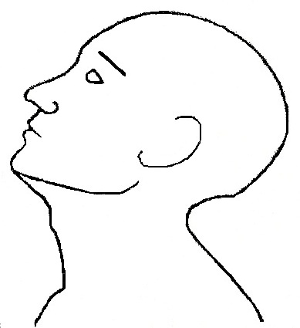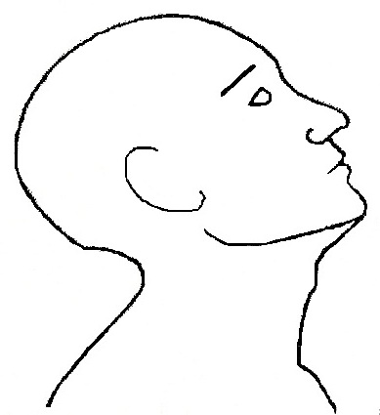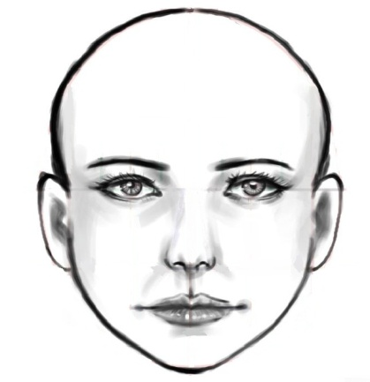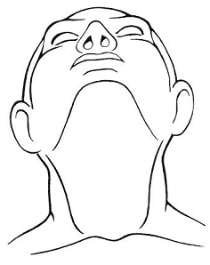

Describe any other injuries or symptoms _______________________________________________________________________________
_______________________________________________________________________________________________________________________________________

OFFICER CHECKLIST

If strangled/suffocated with object(s), photograph object(s) and collect for evidence. Document where the object(s) was/were found in the Offense Report. Determine if jewelry was worn by either party (ring(s), necklace(s), watch(es), etc.). Photograph / look for patterns and photograph. If defecation or urination in clothes, collect clothes as evidence. If Victim vomited, take a photo of vomit. Call On-Call Domestic Violence Detective if you need assistance. Call On-Call Domestic Violence Detective if Victim is transported to the hospital from injuries due to strangulation/suffocation.
Advise on future symptoms (headaches, throat/neck pain, etc.) Advise victim that she/he should be with somebody, and should not be alone for 24 hours. Who will you be with? ____________________________ Contact number: __________________________
If Victim is transported to the hospital from injuries due to strangulation/suffocation then an officer NEEDS to standby at hospital until relieved by the On-Call Domestic Violence Detective.
PHOTOGRAPH SUSPECT: hands, arms, face, chest and any areas where Suspect states any injuries/contact occurred.

